**Using a UPS to Prevent Loss of Power**

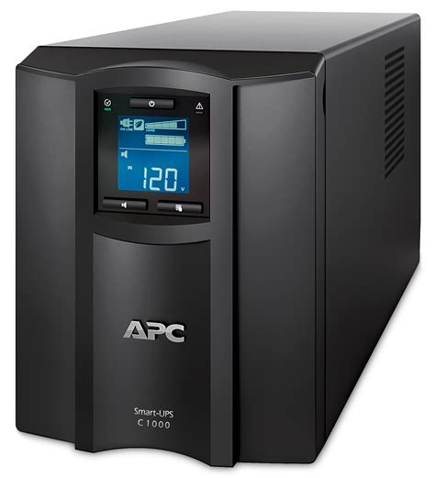

**Introduction**

In the business world, a power outage can mean lost business and potentially lost data. The use of an uninterrupted power supply is crucial in preventing the negative effects caused by a power outage. It does this by means of a battery which supplies power to crucial components if power is lost. This means that a business can keep their network and POS system(s) safe & operational long enough to save and shutdown. This guide is to instruct you how to pick the appropriate UPS for your needs.

**Step 1: Define what devices need battery backup and which just need surge protection.**

1. **Battery:** i.e. computer, POS, electronic safe, router/firewall, and WiFi access points.
   1. Ask: What devices are “mission critical”? Make a list of these devices.
2. **Surge Protection:** i.e. phone, lights, etc.
   1. Ask: What devices are not “mission critical” but still could use protection from electrical surges? Make a list of these devices.

**Step 2: Determine the power usage of the devices you wish to have battery backed up.**

**Option 1:**

1. Use an inline power meter to measure the wattage of the chosen devices. Note the results from all devices.
   1. I suggest using the kill-a-watt electricity usage monitor.

[https://www.amazon.com/P3-P4400-Electricity-Usage-Monitor/dp/B00009MDBU](https://www.amazon.com/P3-P4400-Electricity-Usage-Monitor/dp/B00009MDBU/ref=sr_1_5_mod_primary_new?keywords=kill-a-watt&qid=1693268887&sbo=RZvfv%2F%2FHxDF%2BO5021pAnSA%3D%3D&sr=8-5&th=1)

1. Total the values from step A and use the result in a ups selector

<https://upsselector.eaton.com/Load>

**Option 2:**

1. Use a UPS calculator to estimate power usage based on equipment list.

<https://tripplite.eaton.com/products/load-calculator>

**Step 3: Use usage figures to select an appropriate UPS to meet your needs.**

Consider These:

1. **Low-End UPS:** 200va - 750va | 1 - 10 minutes depending on load %.
   1. Good for brownouts and allowing user to save and shutdown devices during power outage.

Examples:

<https://www.apc.com/us/en/tools/ups_selector/home/entry?powerUnit=w&minPower=200&maxPower=450>

<https://www.apc.com/us/en/tools/ups_selector/home/advanced?powerUnit=w&minPower=451&maxPower=750>

1. **High-End UPS:** 750va+ | 1min - 1+ hours depending on load %.
   1. Good for continued operations during brownout and power outages.

Examples:

<https://www.apc.com/us/en/tools/ups_selector/home/performance?powerUnit=w&minPower=751&maxPower=1200>

**Step 4: Connect devices to the UPS.**

1. The UPS will be labeled indicating which plugs are wired to the battery backup and which are just surge suppressed.
2. Plug the devices you determined to **NEED** backup power on the plugs labeled battery backup & surge protection.

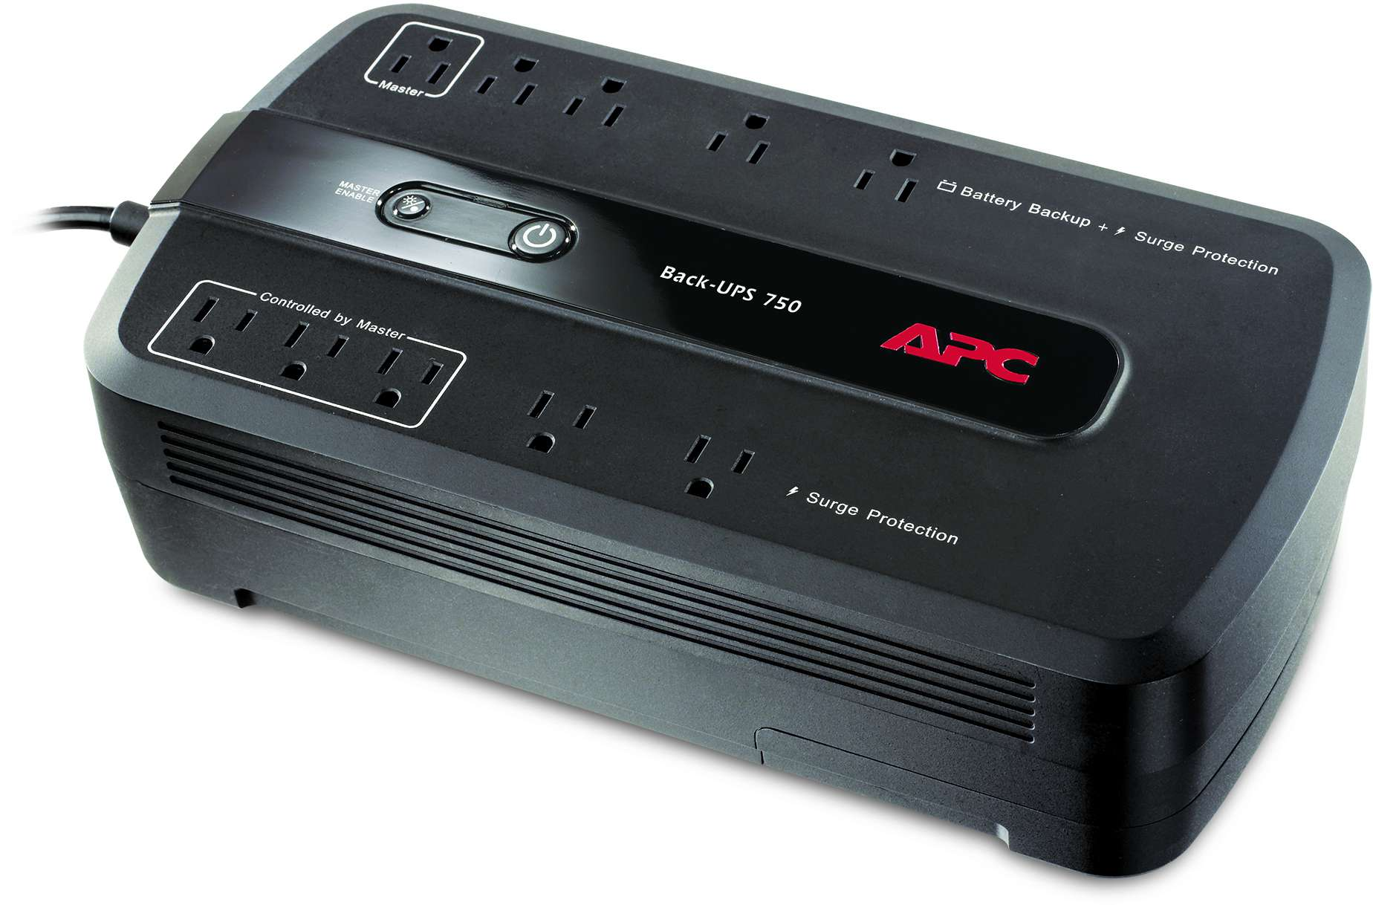

1. Plug the devices that **DO NOT** need backup power on the plugs labeled surge protection.

